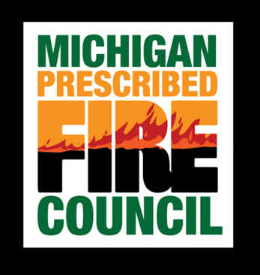
Basic Firefighter (FFT2) Training Information

The initial course work described below provides the minimum training needed to apply for Firefighter Type 2 positions; you must also be able to pass a fitness test. Completion of these courses does not qualify you to fight fire – only an NWCG member agency or organization can qualify you and issue a qualification (red) card. The Michigan Prescribed Fire Council does not issue qualification (red) cards.

For information about employment, click on how to become a firefighter:

Who can take this training?
The Michigan Prescribed Fire Council can provide this training as an affiliate of NWCG through its members. By registering with MPFC, you will receive the name of a course administrator that will be available to assist you with questions regarding the course work. Registration will open when the Training and Certification Committee determines there is sufficient interest; submit the Course Interest Form to indicate your interest.

How much does it cost?
There is no cost for the online courses. Registration costs for the field day required to receive the full FFT2 certification vary depending on the course offered.

Required course work for Firefighter Type 2
Before you can begin…

- Register for a FEMA Student ID: https://cdp.dhs.gov/femasid/register

- Have access to a working printer. Save hard copies of the certificates received at the end of the modules and bring them to the field days. YOU MUST PRESENT COPIES OF ONLINE CERTIFICATES TO RECEIVE FIELD DAY CERTIFICATES.

S-110 Basic Wildland Fire Orientation
This course is available here. It is a video which provides information on personal preparedness and responsibility, mobilization, incident procedures, proper clothing and equipment, and living conditions in wildland fire camps. This course is designed for personnel without previous wildland fire position experience. Additional information about the course can be found in the Field Manager’s Course Guide (PMS 901-1).

S-130 Firefighter Training & L-180 Human Factors in the Wildland Fire Service
A combination of S-130 and L-180 is now available online here. It addresses the foundational skills universal to all wildland firefighters and exposes students to human performance concepts as part of basic wildland firefighter training. The material is broken into twelve on-line modules (1 to 3 hours each) and a mandatory, instructor led field day exercise (Module 13). Each on-line module explains the concepts and skills that will be performed and evaluated on the field day. Module twelve contains optional knowledge areas (pump operations, map and compass, fire investigation and cultural resources) that are useful concepts. Although the title to Module twelve implies that it is optional it is required – the concepts are optional paths that you may consider in your firefighter career path. Additional information about the course can be found in the Field Manager’s Course Guide (PMS 901-1).

S-190 Introduction to Wildland Fire Behavior
This course is available online here. It provides instruction in the primary factors affecting the start and spread of wildfire and recognition of potentially hazardous situations. S-190 is typically taught in conjunction with or prior to S-130 Firefighter Training. The material is broken into three on-line modules. S-190 is a prerequisite to S-130. Additional information about the course can be found in the Field Manager’s Course Guide (PMS 901-1).

Certification
Upon completion of an NWCG-sponsored Field Day, acertificate will be issued for S-190, S-130 and L-
180, thus giving you Firefighter Type 2 (FFT2) status.

Trouble Shooting Registration
Make sure you:
- Are using a supported web browser
- Have the correct version of Java installed and enabled
- Have the correct version of Flash player installed and enabled
- Have Adobe Reader installed and enabled

Contact Information
Ryan Koziatek, MPFC Course Administrator
Kalamazoo Nature Center
7000 N. Westnedge Ave
Kalamazoo, MI 49009

email: rkoziatek@naturecenter.org
phone: (269) 491-0488
fax: (269) 381-2557

