2023 MI PFC Strategic Planning Meeting Information

Which Best Describes your affiliation:
Top 3: NGO/Non-Profit, Local Government, State Agency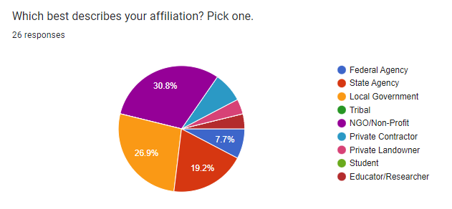

What is your preferred method of comm:
E-mail Majority, followed by Text
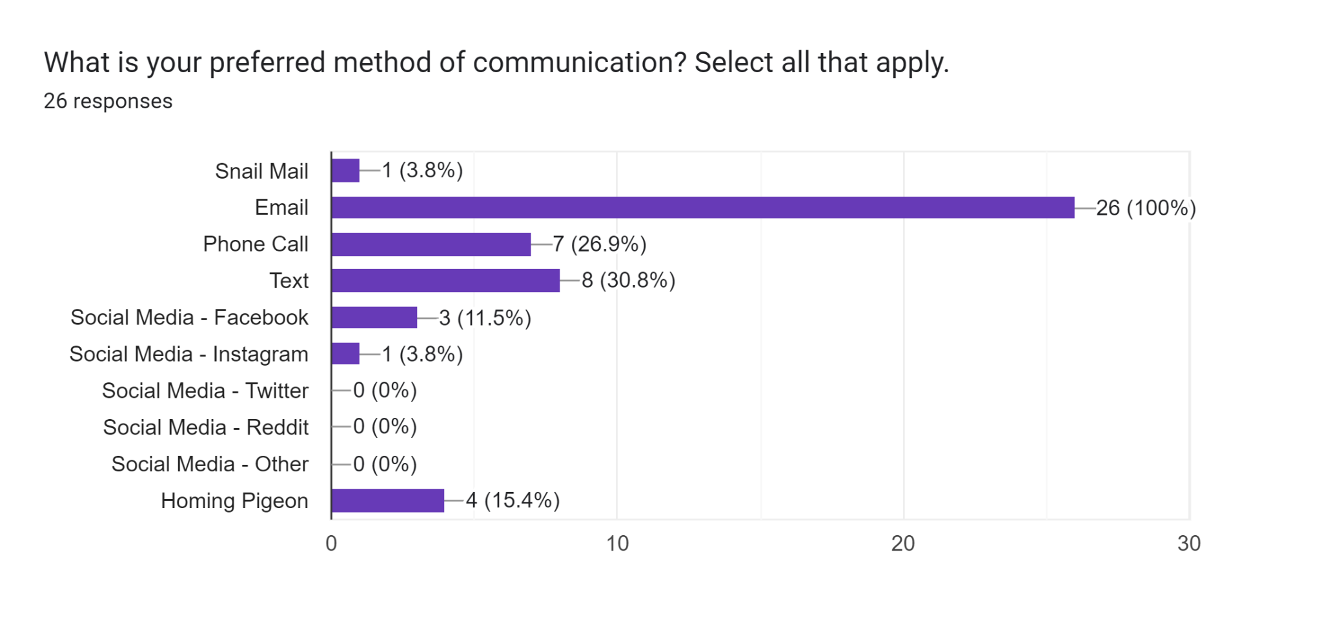
How would you prefer to attend future MI PFC meetings and/or events:
Hybrid/In-person (Southern Lower) tie for highest
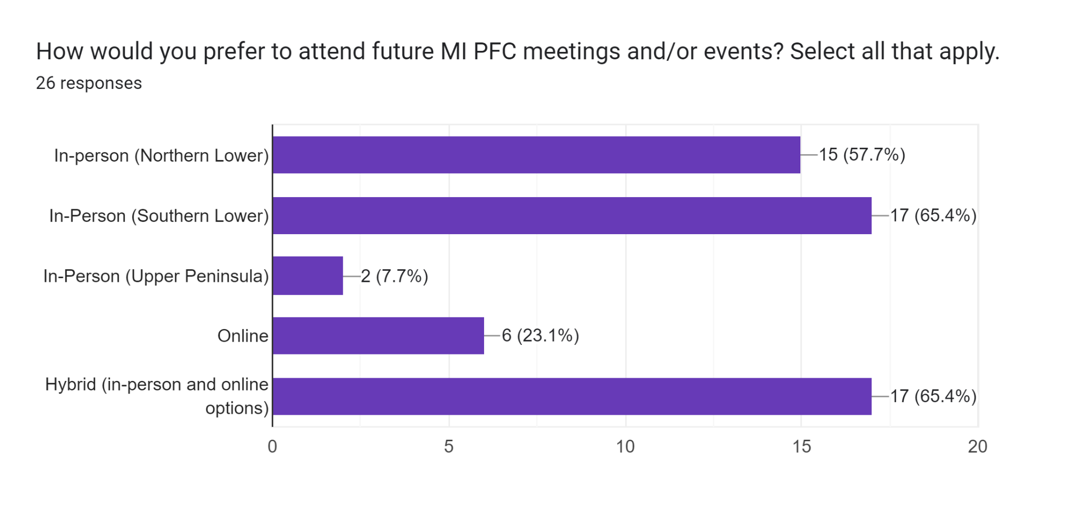

In your opinion, what types of future actions/events/trainings/etc. would benefit the Rx fire community?
RANKED ORDER
- Field Trainings: hands on trainings to gain experience (TREX, crew boss) and for volunteers (FFT1/FFT2) (x10), especially in UP and northern lower (x2) Opportunities to volunteer w/other crews -> access to info about them
- Networking Events: More forced networking like strategic planning meeting (x2), association of consulting foresters involvement, More intention invitation of tribal neighbors
- Public Outreach: UP rxfire networking for private landowners/ how to burn (x3), public outreach re: rxfire benefits as mgmt tool and eco-history (x3)
- Research/Info Sharing: Newsletter of case studies
- Shared Resources to increase burn capacity: Burn staffing capacity networking models

Would you be interested in participating in future sessions similar to the one today? Why or why not?
YES = 77% : collaboration/listening to info, not much availability, good sense of supportive community

Unsure/ maybe = 23%

Breakout #1
Who is your current target audience when it comes to Rx Fire?
RANKED ORDER
TOP 4: Private Landowners, Political Movers, Conservation Groups, Recreational land users/Students
- Private Landowners (x18) > Farmers with CRP, neighbors/residents, clients, conservation easements
- Political Movers: Feds, State Employees, Local Officials, NRCS, DNR Townships, Board members, Conservation Districts, forestry (x11)
- Conservation Groups/Clubs: Hunt clubs, conservation groups, NGOs (x9)
- Recreational land users AND students: Park/Preserve/Nature Center users (x5), education/school users, students (x5)
- Tribes (x3)
- Military (x3)
- Local fire depts (x2)

What is the reach of your organization? Who do you currently interact with?
- Tribal land managers seem underrepresented at the conference. Could more outreach to tribal DNR depts improve representation.
- Dominant reach (mostly notification of burning, not education): State/federal orgs, park users/preserve users, elected officials, landowners, hunt clubs, fire depts, townships, general public, private landowner clients, students

Who do you think our collective audience should be here in Michigan?
- Property owners/Land Managers (with fire adapted landscapes) (x12) ->Land Managers specifically (x3)
- General Public/Everyone (x7)
- Contractors/professionals who use fire (x5) ->NGO specifically (x3)
- Political movers (x4)
- Park/Recreational land users (x2)

Tiered approach – council supports practitioners who engage w/public and property owners (x3)

What audience do you feel is being missed by your organizations?
- DIY land managers (x5) > farmers/hunters
- BIPOC (x4)
- Small private landowners (x4)
- General Public: non-property owners, people without land, urban residents (x4)
- Tribal (x2)
- Students/youth (x2)
- Local fire department (x2)
- Conservation Districts
- Federal agency
- local municipalities
- Disabled peoples
- lower socioeconomic
- Northern MI as a whole

If you are not reaching a specific audience, who are they and why do you think they are being missed?
- General public, city dwellers (x12)
- BIPOC (x4)
- Local fire departments (x3)
- Tribes (x2)
- Students (x2)
- federal agencies (x2)
- DIY land managers
- Local municipalities
- specifically Northern MI

Because of:
- lack exposure/communication streams: people without social media aren’t reached, people farther away from burns (not neighbors) are not reached, lack understanding of how to reach those communities (x14)
- lack of public knowledge/understanding for need of rxfire/whole organization lacks reach to these communities (x6)
- lack money (x6)
- lack time (x5)
- staffing capacity/labor (x5)
- lack resources/equipment (x3)
- our services to clients or the opportunities to work with us aren’t accessible because of financial, physical, and resource barriers
- too small of parcels to be economic/efficient
- lack collaboration
- lack of fire on ground (Northern MI)
- lack burn bosses/experienced staff
- lack training

If you could change things to reach a broader audience, would you?
- Yes 50% - but don’t know how to effectively and efficiently
- No 50% - lack capacity/time, small business, haven’t reached primary audience well enough yet

Breakout #2

When it comes to Rx fire, what are your current unmet needs as far as being able to put fire safely on the ground?
- Training/education/hands-on experience/burn boss credentials for private lands (x14, >50% of responses)
- labor capacity (staff/volunteers) (x7)
- Equipment Needs (x7)
- Costs to operate/pay for burn boss or contractors (x3)
- networking/collaboration with fire departments, agencies, other orgs (x3)
- Insurance
- time of year
- Being able to track + report fires statewide
- public distrust of fire
- share of research/study methods

Does the current mission and/or objectives of the MI PFC address any of those unmet needs? Does the current mission and/or objectives of the MI PFC provide any value to your organization at this time?

Yes 32%
No or needs improvements 68%

Notes on MPFC objectives page:
- “build connectivity and cooperatives with the burn practitioners”: facilitate conversations between potential partners (i.e. local fire departments) (x3)
- too focused on fire instead of people, include “people” in objectives, support people already using fire and future fire users
- Make objectives quantifiable
- Too broad/redundant - use specific terminology but allow flexibility
- Smart objectives
- Advocate for policy change to support Rx fire, strategic relationships building for improved knowledge exchange (Tribal DNR, Fire Depts)
- Network to collect and disperse info
- safety first because of public fear of fire
- non-agency support for reliable/regularly scheduled trainings, no trainings available for non-NWCG organizations
- “train and equip”; volunteer-specific trainings
- “enable, facilitate, or coordinate” rather than “promote” safe fire
- network and information dissemination
- Get rid of Obj #3 and include in Obj #4 “Disseminate technical information on rxfire and its application to achieve desired enviro and ecological resource management goals.”
- Get rid of OBJ #5
- OBJ #6 “Sharing inter-agency/cross organizational framework for communications regarding rxfire objectives, techniques, and issues.”
- Promote vs facilitate/support
- model ordinances
- track methods + amounts, track burns statewide
- burn plan writing workshop type trainings/webinars
- contractor list is helpful, more lists/options?
- S130/S190 online trainings

If your breakout group was leading the MI PFC, what would your top priorities be? Incorporating those priorities, feel free to try writing a 1-3 sentence mission statement for the MI PFC.
NETWORK BUILDING
- “MPFC works to support current and future fire practitioners by connecting agencies to share trainings, research, and resources for the safe implementation of fire for ecological resilience.”
- People who practice rxfire are well-equipped to practice and teach rxfire.
- build collaboration, synergy, and competence among the organizations that provide prescribed fire in MI
- develop relationships and partnerships to share personnel, equipment, and knowledge to improve and promote the use of appropriate and safe rxfire.
- current statement is fine but lacks details of how it is implemented
- support research and sharing info from local region. support current and future fire practitioners
PUBLIC OUTREACH
- using rxfire to address ecosystem health and management by providing public outreach and education about the importance of rxfire for healthy wildlife habitat and recruiting new members to get involved with rxfire.
- normalize rx fire as a land management tool
- educating the public that fire was a landscape process on every MI ecosystem. Promoting safe use and reintroduction of fire.
SUPPORT FOR PRIVATE LANDOWNERS
- the importance of burning and how to get resources to accomplish burns.
- provide knowledge and tools to private landowners for using rxfire to make fire on the landscape be “normal”.
- make safe rxfire attainable for anyone who wishes to burn to promote the health and/or safety of their land without prohibitive training requirements or equipment standards
TRAINING FIRE PERSONNEL
- training on all aspects of implementing rxfire (planning, equipping, implementation, monitoring, outreach) AND get a broader group to the table or risk having those groups implement their own fire training and burn associations without MPFC involvement.
- certification and increase training opportunities

Thinking about your answer to the previous question, consider why you want to accomplish that mission. Feel free to try summing up the “why” of your mission statement in a 1-3 sentence vision statement.
NETWORK BUILDING
- “Fire practitioners have support through compiled resources, shared trainings, and cross-organizational collaborations to manage landscapes with fire safely and efficiently for ecological resilience.”
- Facilitate collaboration between entities (make it accessible, don’t need face equip to get it done)
- From instructor to integrate rx fire as culture in MI, Agency & Private owner, other group collaboration red card min
PUBLIC EDUCATION
- Educate the public and recruit new members to educate that fire is an important management tool for fire-dependent ecosystems.
ECOLOGICAL MISSION
- burning for the better of the ecology
- returning ecosystem process to MI landscapes for biodiversity, ecosystem health, and public safety.
- rxfire is good for land, historical resilient ecosystems, reduce fuel load reduce wildfire risk, important for climate change, it’s fun and I love fire.
FIRE CULTURE IN MI
- integrate rxfire into the culture of MI
- the safe use of rxfire is a common and accepted land management tool on public and private land in MI.
- Make rxfire a regular feature of the landscape making it more accepted/normal in the public eye.
TRAINING FACILITATION
- Training for non-NWCG organizations
- increase implementing/educating individuals that are within MI PFC to expand the planning, education, and implementation of rxfire.
- How to keep people involved after trainings?
- Model ordinances
- NWCG Alternatives
LEGISLATIVE SUPPORT
- safe prescribed fire is attainable for any landowner who wishes to exercise their right to burn and that the right to burn is not impinged by the infrequent mistakes or others’ irresponsible use.Encouraging a safe and effective prescribed fire program across the state and aiding in understanding of fire benefits to foster a biodiverse resilient landscape
- Clearing house-tracking burning across state (For Glen’s tracking) – State smoke mgt plan

Breakout #3

What policies and/or attitudes interfere with your ability to increase the use of Rx fire?
#1 BARRIERS TO IMPLEMENT RXFIRE
- TRAINING: limited certification, no burn boss training, no pathway to get/maintain NWCG certs for small orgs,
- STAFFING CAPACITY/LABOR: lack trained volunteers, training Gaps – limited by # of burns by personal
- RESOURCES/EQUIP: limited resources
- FUNDING: advocating to board of directors for funding for rxfire
- WEATHER: finding an appropriate burn day conditions
#2 PUBLIC PERSPECTIVES
- bad PR, media, general fear of fire and a falsely envisioned destructive effect on the landscape like wildfire
- rxfire not a cultural “norm”
#3 LACK NETWORKING
- resistance from local fire departments, perspective/relationships vary across different townships/counties
- private sector lacks collaboration with agencies
- Communication breakdown between structure and wildland FF’s
- Use of fire in residential only DNR but not other agencies, need big engine present but only PR is
- local jurisdictions don’t support private use of rxfire
#4 INSURANCE/LEGISLATIVE
- Rx burn cert-insurance

What would it take for YOU to consider joining MI PFC? What types of roles would you be interested in taking on? What types of activities would you be interested in working on?
MEMBERSHIP LOGISTICS
- Understanding how the council functions
- Knowing how to join/Am I a member (x4)
- Incorporating a membership/annual fee
- Knowing structure and how decisions are made – subcommittees
- make MPFC more accessible
- clarify what is required to be a member/be involved with the council how much time is expected of members
- how are resources developed and shared
BROADER PARTICIPATION/NETWORKING
- Talk with Tribal members to understand what would make participation in MPFC appealing to them
- knowing there is a benefit for my local service area or surrounding region
- awareness is necessary, I would help host education workshops for general public, Conservation Districts could be good partners to educate the public, don’t rely solely on NRCS
- collaboration is key to success and can help all orgs involved
- always a challenge for private contractors to take time to participate, would be more involved with information exchanges
- I’m interested in building capacity/collaboration in SE MI
- more networking and opportunities to share knowledge of experiences
LACK TIME
- I would if I had more free time, specifically to help with admin support not physical burns
- get MPFC support written into grants/job descriptions
- I want to be useful. What can I add? Nobody is asking anything of members
- connections to other groups such as joint meetings with SAF, MUCC, Pheasants Forever, student orgs
- I need my org leadership to approve time and funds for my participation as I don’t have capacity outside of my job
- lack capacity with other jobs we have to do - clarify what is required to be a member/be involved with the council
- I would like to be a general member for now as I am part of various other boards and orgs
WANT TO FEEL USEFUL
- I have not seen any call for help to participate in committees/conference planning, etc so I haven’t been aware of opportunities to be involved.
- interested in planning events/trainings
- interested in event logistics/coordination
- interested in training and outreach
- I can help provide assistance to admin, learn and burns, training for private lands
- Research/monitoring committee
  - Resource to help w/ setting up monitoring
MORE TRAINING NEEDED
- Feeling like I had any input of worth or would have task to do that are of use
- I would have more to contribute after I gain more training/experience
- need to hire a burn contractor and get myself training first
- TREX
- I need more experience before I can feel that I can add anything to benefit the council
VOLUNTEER FIRE CREWS
- Volunteering with other prescribed burn
- interested in trainings and joining on burns

What organizations does your group represent and how could your organizations provide support to others in the Rx fire community?
- Work w/ cross property burns, learn & Burns
- Resource outlet, template or ex of postcards, result summaries, signage common q&a’s, training for public volunteers
- NRCS (limited by policy, time, cert, not sure how we could support others)
- MDNR (NWCG training)
- Landowners and enviro groups (we can provide staff time for some projects like supporting staff capacity on burns and cover costs/increase outreach efforts. we host regular educational workshops on land mgmt and nature-based topics. local libraries could also be a great partner)
- Conservation District (outreach to private landowners)
- Private landowners
- National Guard (partnership with other agencies to offer training sites and input in State regulations/policies)
- Fetzer Institute and GilChrist Retreat Center (property could be used to host rxfire trainings)
- Local parks department
- CISMA
- local government (we can volunteer time/info)
- nonprofit with limited staff can only offer volunteer time right now
- sharing equip and BMPs, give advice, refer people to contractor list
- DNR
- SWMLC (help other communities build rxburn program, learn and burn events)
- foresters
- training academy
- university training
- money and collaboration with MI SAF field days and webinars (reach 350 foresters)

Who can each of your organizations currently provide support to?
- Right to burn
- Action items, knowing what is needed, reaching out to universities, nature centers, tribal rep, other agencies
- pretty limited
- private landowners
- partnering agencies
- local network
- rxfire contractors
- local orgs
- private landowners and nearby NGOs
- training and outreach
- county agencies
- land conservancies
- DNR special position for right to burn in the works
- foresters education/recommendations on silvicultural benefits
- expertise and contract burning
- students
- agency employees
- $10,000 annually from MI Forest Stewardship Program (Mike Smalligan)

What actions that all of us here today can take towards forming a Rx burn community?
- More individual initiative, reaching out to more organizations
- Put out quantitative results, joint meeting with groups like KNC with nearby conservancy, 2025 FW conference
- we need to determine if there is a need for rxfire community in the UP and what they could accomplish
- support one another and brag about successes
- have more contractors
- membership drive, find new partnerships for collaboration
- increase access to trainings and equip, grants, etc
- positive press opportunities for successful fires
- info sharing and communication throughout the year
- conferences and website are great, maybe more can happen over the season to keep group collaboration
- be safe, smart, transparent with controlled burns to help avoid neg public perspective
- involve/educate on the ecological importance of fire
- local advertising
- provide examples of outreach communications
- celebrate rxburns that go well
- resource cache (photos, social media posts, communications, etc.)
- sharing info/education
- NGO partnering to share resources to get fire on ground and trainings
- commitment to attend annual meetings
- share MPFC participation opportunities within local networks
- new MPFC pamphlet
- communications, outreach, work together
- develop training opportunities, cooperative agreements/shared resources among agencies
- rx event for MPFC to participate, 1 day TREX
- in person events
- frequent webinars
- publish MPFC membership list
- publish MPFC bylaws and policies to better explain group
- quarterly newsletter

